# ABSTRACT OF THE DISSERTATION

Title

by John Braley

Dissertation Director:

Franklin L Moon

Begin text here.

# Table of Contents

ABSTRACT OF THE DISSERTATION ii

Table of Contents iii

List of Tables v

List of Illustrations vi

Introduction 1

Heading 2 2

Heading 3 2

Part 1: Understanding vehicle-bridge interaction and dynamic amplification 3

Experimental Case Study 3

Description of Test Structure 3

Phase 1 Testing 4

Phase 2 Testing 5

Phase 3 Testing 7

Test Conclusions 11

Simulating VBI 11

Bridge and vehicle decoupled 12

Mechanisms and Influential Attributes 12

Part 2: Estimating Dynamic Amplification 15

Visualizing the Problem 16

In-Situ Measurement 17

Operational Monitoring 17

Load Testing 18

Profile Measurement 19

Finite Element Analysis 19

2D Condensation & State-Space 21

Description 21

Implementation 22

Validation and Performance Assessment 23

IRI & Other Vehicle-Only Models 25

Summary 27

Part 3: Applications in Vehicle-Bridge Interaction 27

Remediation and Smoothness Criteria 27

Vehicle Configurations 29

Traffic 29

Truck Trains 29

Future Work 29

# List of Tables

# List of Illustrations

# Introduction

This document aims to explain and demonstrate the behavior of a bridge under a moving vehicle. Before I embark on that effort I feel obliged to define a few terms that you may notice to abound throughout the following pages.

The first is “vehicle-bridge interaction” (VBI), which refers to the scenario in which one dynamic system (vehicle) traverses a second dynamic system (bridge). The vertical translation of the vehicle is coupled to that of the bridge at the wheel contact locations. Vehicle-bridge interaction therefore refers to the behavior of the combined system.

The second term is “dynamic amplification”, which quantifies the inability of static analyses to predict the maximum response of a dynamic system. It is expressed as a ratio of maximum dynamic response to static response. For a bridge, moving vehicles excite the coupled system resulting in bridge motion which in turn causes member level responses unequal to those that would result from the force of the vehicles’ weight alone (static).

For many civil applications, static analyses have proven adequate for determining the demands of structures. Structures often remain near enough to a motionless state that the structure can be described as a static system, and the resulting error from employing this assumption can be accounted for with a small increase in the factor of safety. However, in other cases, the deformation experienced by a structure associated with its motion is appreciable, as is seen in seismic events.

Live load demands have historically been estimated using static analysis. The dynamic amplification factor that should be used depends on the design specification with jurisdiction. According to AASHTO, a maximum factor of 1.33 is to be used. However, there have been numerous reports of bridges experiencing dynamic amplification well in excess of this number. Extensive structural monitoring was performed on one such nonconformist as detailed herein.

These bridges with excessive dynamic amplification suggest that old assumptions are no longer conservative for every bridge. We are therefore compelled as designers, builders and operators to identify the shortcomings of old assumptions and develop more accurate methods as required.

# State of the Art

## Heading 2

### Heading 3

#### Heading 4

Text: The quick brown fox jumps over the lazy dog. The quick brown fox jumps over the lazy dog. The quick brown fox jumps over the lazy dog. The quick brown fox jumps over the lazy dog. The quick brown fox jumps over the lazy dog.

The quick brown fox jumps over the lazy dog. The quick brown fox jumps over the lazy dog. The quick brown fox jumps over the lazy dog. The quick brown fox jumps over the lazy dog. The quick brown fox jumps over the lazy dog. The quick brown fox jumps over the lazy dog.

More information can be found here: [https://gsnb.rutgers.edu/academics/electronic-thesis-and-dissertation-style-guide#sample](https://gsnb.rutgers.edu/academics/electronic-thesis-and-dissertation-style-guide%23sample).

Image Placeholder

Figure 1: Test Image

# Part 1: Understanding vehicle-bridge interaction and dynamic amplification

This first part details the experimental testing and investigation of a real bridge and documents the knowledge gained from such efforts. Recording a phenomenon is the first step in understanding it.

## Experimental Case Study

The case structure was brought to our attention by local transportation officials. By their report, motorists have repeatedly contacted local police to report what they perceived to be excessive vibration. This prompted a series of field tests in which various structural responses were recorded under typical operational conditions. Testing objectives were driven by the DOT’s directive to identify and characterize the bridge vibration and determine if they may be detrimental to the structure’s performance. The testing activities, results and conclusions are summarized in the following sections.



### Description of Test Structure

The structure is an 11-span viaduct that carries 4 lanes of a major interstate highway. The viaduct was first constructed in 1952 but the superstructure was replaced in 1986 while retaining the concrete piers. East bound and west bound lanes are carried by adjacent steel multi-girder spans, which are supported by steel box-girders spanning between two piers. The structure was overall in good condition with no significant cracking or corrosion visible.





#### Superstructure

The structural type is steel multi-girder. Eight girders run longitudinally, resting on steel box girders that span transversely and are supported by the concrete piers. A reinforced concrete composite deck was cast in place, with a “raked” finish and no overlay. The deck is discontinuous between girders 4 and 5, thereby creating two adjacent structures.



Figure 2: View of Deck Separation

There is no skew. The bridge has eleven spans. The maximum span length is 140’-0”. The out-to-out width is 76’-6”. Three spans are simply supported (1, 2 & 11), while the remaining eight are two-span continuous. Each span has five interior rows of X-framed diaphragms and chevron diaphragms over the piers. The following figure enumerates the girder layout which will be referenced in the following sections.



#### Substructure and Bearings

The concrete piers and abutments were constructed in 1952 and are all that remains of the original structure. They are supported by driven piles. Elastomeric bearing pads are installed on top of the piers and support the transverse box girders. Rocker bearings or pedestals are installed between the box girders and longitudinal girders at those locations which are in the center of continuous spans. Elastomeric bearings are installed between the box girder and the longitudinal girders at the remaining locations.



#### Condition

Visually, the deck appears to be in good condition, with no major cracking visible. Minor damage was observed in some regions of the center concrete barrier. The girders appeared in excellent condition. No major rusting was observed, and the girders appeared well maintained. The access hatches on many of the box girders had been left open. Any ill effects from this could not be immediately observed. The piers exhibited very little efflorescence and virtually no spalling. Repairs had been performed on several piers, where an embedded drainage pipe had rusted and caused a portion of concrete to spall off.

NBI Details

| NBI Structure Number | 000000000027280 |
| --- | --- |
| Year Reconstructed | 1986 |
| Owner | PennDOT |
| Skew | 0 degrees |
| Deck Width | 76’-6” |
| Maximum Span Length | 140’-0” |
| ADT | 57410 (2013) |
| Deck Condition | 6 (Satisfactory Condition) |
| Superstructure Condition | 7 (Good Condition) |
| Substructure Condition | 5 (Fair Condition) |
| Sufficiency Rating | 70 |

### Phase 1 Testing

The objective of the first phase of testing was to merely survey the structure so as to determine which portions of the structure were experiencing large vibrations, and begin to characterize those vibrations that may be “problematic”. Testing of the viaduct took place on July 6th and 7th of 2016.

#### Instrumentation Plan

The cross girders at piers 2, 3, 5 and 7 were instrumented with accelerometers to determine which spans experienced the highest levels of vibration. The accelerometers were positioned to capture the motion of the cross girder. On select cross-girders, accelerometers were positioned on one end of the cross-girder, on the bottom flange at mid-length, and on the web over the piers. These locations would provide information on the motion of the cross-girder in the vertical, longitudinal and transverse directions.





All accelerometers were attached to the steel structure with magnets. Data was sampled at 200 Hz for several hours.

#### Results and Interpretation

The resulting acceleration data was compared by examining and comparing time-histories for different cross-girders. All instrumented cross girders experienced similar levels of vertical and longitudinal acceleration, while the cross girder at pier 7 experienced much higher transverse acceleration. The transverse acceleration time history is shown below, while those for vertical and longitudinal acceleration are provided in the appendix.

|  |  |  |
| --- | --- | --- |
| Acceleration (g) |  | Pier 2 |
|  | Pier 3 |
|  | Pier 5 |
|  | Pier 7 |
|  | Time (sec) |  |

Figure 3: Transverse Acceleration Time Histories

To further compare acceleration the root-mean-square (RMS) was computed for each location over a period of 28 minutes. Because of the cyclic nature of structural acceleration that is nearly symmetrical about the zero line, an average of the data would return a value very close to zero. It is for this reason that the RMS was employed. A comparison of the RMS values at different locations is compared in the following charts.

Pier 2

Pier 3

Pier 5

Pier 7

It is suspected that the vertical motion of the bridge is that most felt by motorists and thus the response that should be most influential for deciding the region to perform further testing. However, as can be seen in the RMS comparisons above, the vertical acceleration is consistent between locations. While the longitudinal acceleration RMS does differ at different locations, the two sides (east and west) do not have consistent trends and therefore fail to identify a region of high excitation. Furthermore, while the RMS value for transverse acceleration clearly point to Pier 7 as experiencing the greatest excitation, it is uncertain that this direction of motion is indicative of the vibrations that have been reported and that are the subject of investigation. It can therefore be concluded that the bridge is experiencing similar levels of vibration across many or all of the spans.

Spans 7 and 8 were subsequently chosen for further testing. This decision was based on the available access to the superstructure as well as the evidence that span 7 may be experiencing slightly higher vibrations. It was also hypothesized that the taller piers supporting spans 7 and 8 would provide greater flexibility thus permitting greater deformation and more vibration.

### Phase 2 Testing

The objectives for the second phase of testing were (1) to characterize operational vibrations and strains at critical locations and locations of maximum response under various traffic conditions, and (2) to gather data for modal parameter identification (i.e. frequencies and mode shapes).

Instrumentation of spans 7 and 8 was installed on July 26th and 27th of 2016. Data was recorded on July 27th and 28th. Sensors were removed on July 29th.

#### Instrumentation Plan

A total of 30 accelerometers (PCB Model 393A03) and 12 strain gauges (Geokon 6" vibrating wire) were installed on the chosen region of the viaduct (span 7 & 8). The sensor locations are best described by the layouts provided in the following figures.



Accelerometers were positioned on the structure to capture several natural modes of vibration. They were therefore installed at locations that experience the greatest displacement for a given mode shape and at sufficient locations such that different modes may be distinguished from each other. By placing accelerometers as quarter-span, mid-span, and three-quarter span the first and second bending modes may be obtained. They are distributed transversely to capture torsional and butterfly modes. Span 8 received far fewer sensors due to a utility line that impeded access to much of the span. However, accelerometers were able to be installed along the first quarter-span line and provide the necessary data to determine the relative phase between spans for a given mode shape.

Strain gauges were installed to provide information on the stress inducing deformation of the structure and the influence of vibrations on that deformation. Gauges were therefore installed at locations expected to experience the greatest strain (i.e. mid-span & negative moment region) as seen in the instrumentation layout provided below.



#### Test Activities

Accelerometers were attached to the steel superstructure with magnetic bases and attached to the concrete face of the piers with hot-glue (thermoplastic adhesive) after the surface had been cleaned with a steel-wire brush. Cables were clamped to the structure near the gauge to prevent the weight of the cable from damaging the gauge or affecting the readings.



Strain gauges were installed by epoxying the mounting blocks to the steel surface. The surface was prepared by sanding off the paint until clean, bright steel was observed. The epoxy was allowed to cure for several hours before the gauges were locked into the mounting blocks. Tape was used to affix the gauges while the epoxy set. Cables were managed in the same manner as was done for the accelerometers.



All accelerometers were sampled with a National Instruments CompactRIO (cRIO) controller outfitted with NI9234 modules for acquisition of the dynamic data. Data was gathered at 200 Hz for a total of 14 hours to capture the behavior of the bridge under differing operational conditions (e.g. rush-hour vs free-flowing traffic).

Strain gauges were sampled with a Campbell CR3000 datalogger along with (2) CDM-VW305 (Dynamic Vibrating-Wire Analyzer). Strain was sampled at 50 Hz for 12 hours and at 20 Hz over-night.

All gauges were removed from the structure at the conclusion of data collection. Paint was applied to areas that had been sanded.

#### Results & Interpretation

##### Characterization of vibrations through acceleration data

The acceleration data was filtered to remove high frequency content for time history plots as the high frequency content is associated with minimal structural deformation and therefore is of less interest. A low-pass elliptic filter was chosen for its steep cut-off slope. The filter was assigned an upper pass-band limit of 20 Hz, a pass-band ripple of 0.5 decibels, and 40 decibels of stop-band attenuation. The frequency response of the resulting filter can be seen in the following figure.



Figure 4: Frequency response of 6th order Elliptic filter

A sample time-history of acceleration with the above filter applied is shown below for girder 5 at midspan.



Over a period of 24 hours frequent traffic events were recorded for which the structure experienced acceleration greater than 0.2g. One such event is plotted below (Girder 5 at midspan of span 7). It is readily apparent that the structure is experiencing relatively low-frequency oscillations.



Spectral analysis of the records confirms that much of the motion occurs at low frequencies; between 2 and 4 Hz. The image below shows the power spectral density (PSD) for several locations, estimated using Welch's overlapped segment averaging (100 second segment lengths with 25% overlap and a total record length of 4.5 hours).



As can be seen from the spectral analysis plot, the majority of the vibration being experienced by this superstructure is occurring at frequencies between 2 and 4 Hz.

To estimate the displacement associated with these low-frequency vibrations the acceleration is first transformed into the frequency domain with an FFT, converted to displacement (divided by the radial frequency squared) and then transformed back to the time domain with an inverse FFT. To examine the displacement associated with a specific frequency range, only those frequency components within the specified range are included in the inverse FFT. In this manner the event previously presented (midspan of girder 5) was analyzed and is plotted below. Note that this displacement estimate considers only frequency content between 1.5 and 5 Hz and thus only represents a portion of the motion experienced by the bridge.

****Based on the displacements identified in the previous figure, the vibrations may be assessed against human comfort criterion. According to that set forth by Reiher and Meister (1931) and illustrated in the following chart, the bridge motion would be classified as “very disturbing” thereby confirming that the measured response is the same phenomenon being reported by motorists. Furthermore, the deformation of the structure associated with this vibration is roughly 0.15 in. and therefore is likely to amplify to the live-load demands. The proceeding sections strive to quantify that amplification.



##### Modal parameter estimation with acceleration data

Modal parameter estimation was performed using the Complex Mode Indicator Function (CMIF) to extract the first 18 natural modes of vibration and their corresponding frequencies. They all occur within a frequency range of 2 to 10 Hz. The CMIF is plotted below with the peaks manually identified.



Due to the symmetric nature of the structure and the superstructure separation between the interior-most girders, many of the modes are quite similar in shape. Therefore only a select few are plotted below while the remaining may be found in the appendix. The mode shapes and frequencies will be used for model calibration.

|  |  |
| --- | --- |
|  |  |
|  |  |

##### Quantifying dynamic amplification with dynamic strain data

The strain experienced by the bottom flange of select girders at midspan is provided in the following plot. As can be seen, these bottom flanges are frequently experiencing (tension) strains greater than 150 µε. This strain corresponds to approximately 4.5 ksi of stress for steel. 

These girders consistently experienced the highest strain levels. The number of events exceeding different thresholds over a 24-hour period for girders 4 and 5 (midspan, bottom-flange) is depicted in the following figure.

Figure 5: High-strain event occurrence count over 24 hours

The following plot depicts one of these high-strain events.



In the above plot the filtered strain is also plotted for comparison. A low-pass elliptic filter was applied with an upper pass-band limit of 1.5 Hz, a pass-band ripple of 0.5 decibels, and 40 decibels of stop-band attenuation. The frequency response of the resulting filter can be seen in the following figure. This filter effectively removes the dynamic component thereby providing an estimate of static response. The event featured in the above plot exhibits a dynamic amplification of almost 2.0. Furthermore, this amplification is occurring at design-level load events.



The dynamic amplification is also affecting the stress in the deck. The uplift experienced by one span when the load is applied to the other span causes the deck to experience tension. The strain experienced by the deck can be extrapolated from the bottom flange and web strain readings assuming a linear strain profile for the cross-section. The measured and extrapolated strains for a typical large-strain event are provided in the following plot. Accordingly, the deck is routinely experiencing tension strain of 100 or greater in the “positive moment” region. Concrete strains of this magnitude are known to initiate long-term fatigue cracking **(cite)** and therefore may pose a threat to the continued performance of this structure.



The strain for the bottom flange in the negative moment region (girder 4) is plotted for the same time period as shown above and is frequently exhibiting compressive strain over 50 µε.



#### FE Simulation

A 3D element-based model of spans 7 & 8 was created. The model was calibrated/validated with the mode shapes and frequencies obtained experimentally. Multiple parameters were explored as a part of the calibration process. Ultimately, once the barrier stiffnesses were adjusted, the model achieved close agreement with experimental results.

##### Element-Level Method of Analysis

This type of model employs both one-dimensional (frame/beam elements) and two-dimensional elements (plate or shell elements) to model girders/diaphragms and the deck, respectively. Beam elements have 2 nodes with 6 DOFs each. Plate/shell elements may have 3 (in the case of triangular elements), 4(in the case of rectangular elements), or up to 9 (in the case of 9-node rectangular shells) nodes with up to 6 DOFs each. In an effort to remain consistent with the three-dimensional geometry of the structure, various link elements (to connect girders to the deck and diaphragm elements to the girders) and constraints (to simulate boundaries) are also employed. This model resolution is commonly termed “element level” and is the most common class of 3D FE models employed for constructed systems (Çatbaş et al., 2013). The figure below shows a schematic illustrating how 3D geometry of the bridge is simulated using various elements and links.



Shell



Beam



Beam



Rigid Link



Figure 6: Schematic of Generic Element-level FEM Model

In this model type the girders are discretized into 1D beam elements and the cross-sections are considered through the definition of geometric constants (e.g. area, moment of inertia, etc.). While an element-level FE model can reasonably simulate most bridge responses, it is not without its shortcomings, specifically: (1) an inability to effectively simulate warping deformation of girders (associated with torsion), and (2) an inability to simulate localized stresses (i.e. stress concentrations) associated with geometric discontinuities. While these shortcomings may be critical in the case of modeling specific construction sequences for complex bridges (White, 2012) and advanced fatigue/fracture assessment, they are not relevant for the global behavior being investigated. A model of spans 7 and 8 was created that included the entirety of the superstructure from the cross-girders to the concrete barriers. All elements were rigidly connected at coincident nodes except as specified. Full composite action was assumed and enforced by using rigid links to connect the girder nodes to the deck nodes. The image below shows a cross-section of the model and the reduction of 3D bridge elements to plate, beam and link elements.



The concrete piers were initially included in the model, but sensitivity studies showed that these additional elements had little impact on the model behavior of interest. The piers were therefore reduced to nodal restraint at the location of the connection between cross-girder and pier. Boundary conditions were applied to a node located at the bottom of the cross girder which was attached to the cross-girder element nodes with a rigid link. The following table summarizes the boundary conditions applied to the cross girders. Spring stiffness was assigned for rotation about the Z-axis to account for the stiffness provided by the elastomeric bearings.

|  |  |  |  |  |  |  |  |
| --- | --- | --- | --- | --- | --- | --- | --- |
|  | DX | DY | DZ | RX | RY | RZ |  |
| @ East Piers | F | F | F | F | R | S |
| @ West Piers | R | F | F | F | R | S |
| F – fixed; R – released; S - spring | | | | | | |

##### Bearings and Pedestals

The stringers were supported by elastomeric bearings, rocker bearings and pedestals. In all cases rigid links were used to connect the various elements at their nodes. Nodes were also placed at locations corresponding to the bottom surface of the stringers and the top surface of the cross-girder as illustrated in the following figure. An element (red) was subsequently placed between these nodes with attributes appropriate for the type of bearing/support.



For pedestals this element was simply a rigid link (XYZ-space). Links that were rigid in only the XY-plane (normal to bridge length) were used for rocker bearings thereby allowing longitudinal motion of the stringers while maintaining vertical rigidity and transverse stability. For elastomeric bearings, the same XY-plane rigid link was used in addition to a spring-damper element that spanned the same two nodes. The spring-damper element allowed the stiffness of the elastomeric to be included with its transverse stiffness parameter (axial and torsional stiffness values were set to zero).

##### Model Validation

Any FE model will inherently have uncertainties. These are due to modeling decisions and assumptions made during the creation of the model such as material properties and connection fixity. The uncertainty of the model can be greatly reduced by comparing simulated responses to the measured responses of the real structure, and strategically adjusting the model until acceptable agreement is achieved. The model of spans 7 and 8 was manually calibrated using the mode shapes and frequencies obtained as part of operational monitoring. The initial model agreed reasonably well with the experimental mode shapes and frequencies but for the first mode, the model failed to predict the torsional deformation of the structure displayed by the experimental mode shapes. This suggested that those parameters which target the mass and stiffness of the exterior portions of the structure should be chosen for calibration.

|  |  |
| --- | --- |
| Experimental | FEM (uncalibrated) |

The following model parameters were addressed as part of the calibration process:

* Stiffness of interior barriers (modulus of elasticity)
* Material density of interior barriers
* Material density of exterior barriers
* Continuity of exterior barriers over continuous support
* Transverse stiffness of stringer elastomeric bearings (spring-damper elements)

Additional scrutiny of bridge photos revealed that the interior barriers appeared to be sawcut at regular intervals. This was reflected in the model by negating the stiffness of the interior barriers by setting the modulus of elasticity to a near zero value. Sawcuts in the exterior barriers over the continuous support were represented by releasing the corresponding elements’ moment and shear in all directions.

The values of the adjusted parameters as well as a few other key parameters are summarized below.

|  |  |  |  |
| --- | --- | --- | --- |
|  | Initial Values | Calibrated Values | units |
| E of Interior Barriers | 3982736 | 5.0 | lb/in2 |
| Density of Interior Barriers | 0.086705 | 0.104047 | lb/in3 |
| E of exterior barriers | 3982736 | 3982736 | lb/in2 |
| Density of Exterior Barriers | 0.086705 | 0.104047 | lb/in3 |
| Elastomeric bearing transvers stiffness | 1E+09 | 1E+08 | lb/in |
| E of deck concrete | 4490369 | 4490369 | lb/in2 |

The natural frequencies of the calibrated model are compared in the table below. As can be seen this revision yielded a model in close agreement with experimental data and can therefore be considered a reasonable digital representation of the structure. There were several experimental modes that the model did not obtain. However, these modes were nearly identical to other modes and differ only in the relative phase of the two sides of the bridge. Plots of experimental and FEM mode shapes can be found in the appendix.

Table 1: Frequency of Mode Shapes from Experimental Data and FEA

|  |  |  |  |  |
| --- | --- | --- | --- | --- |
|  | Exp. | FEM | FEM (cal.) | % diff |
| Mode 1 | 2.00 | 2.73 | - |  |
| Mode 2 | 2.03 | 2.37 | - |  |
| Mode 3 | 2.10 | 3.22 | 2.04 | -2.7% |
| Mode 4 | 2.44 | - | 2.31 | -5.4% |
| Mode 5 | 2.51 | - | - |  |
| Mode 6 | 2.54 | 3.77 | 2.58 | 1.6% |
| Mode 7 | 2.83 | 3.71 | 2.95 | 4.3% |
| Mode 8 | 2.93 | - | - |  |
| Mode 9 | 3.20 | - | 3.45 | 7.7% |
| Mode 10 | 3.34 | 4.58 | - |  |
| Mode 11 | 3.52 | - | 3.65 | 3.8% |
| Mode 12 | 3.56 | 4.25 | 4.06 | 14.0% |
| Mode 13 | 3.56 | - | 4.07 | 14.2% |

##### Refined Load Rating

The calibrated model was used to assess the impact of observed dynamics on the bridge’s ability to carry load and its continued performance by computing refined load ratings of the stringers (positive flexure) using the procedures provided in the *Manual for Bridge Evaluation* (MBE)(AASHTO, 2018).

Member capacity was computed using the equations provided in the LRFD standard specifications (AASHTO, 2014). The nominal moment capacity of the composite section was used for the positive moment region rating (0.4X span length). Dead load, superimposed dead load, and live load demands were computed using the FE model. Live loads were applied according to the AASHTO HL-93 live load model. The recommended impact factor of 1.33 was used as well as the measured value of 1.75. A more extensive description of rating through refined analysis is provided in the **appendix**.

Table 2: LRFD flexural ratings using refined analysis for 0.4 of span length

|  |  |  |  |  |
| --- | --- | --- | --- | --- |
|  | IM = 0.33 | | IM = 0.75 | |
|  | Strength I | Service II | Strength I | Service II |
| Girder 4 | 1.60 | 1.73 | 1.21 | 1.32 |
| Girder 5 | 1.86 | 1.98 | 1.41 | 1.50 |

Refined load ratings revealed that due to design conservatism there was sufficient reserve capacity to handle dynamic amplification even as high as 1.75. Furthermore, the calibrated FE model had parameter values (material properties, element connectivity, etc.) all within very reasonable bounds (i.e. there are no structural abnormalities contributing to the vibration issues). This iteration of testing therefore concludes that although the bridge is experiencing large vibrations, it does not appear to pose a risk to the bridge’s performance. However, the test results and simulations are unable to identify the cause of the vibrations.

### Phase 3 Testing

Previous testing demonstrated that vehicles were capable of exciting the mass of the structure. It became clear that we needed to better understand the coupled behavior of bridge and vehicle as it traversed the bridge. A test was therefore designed to capture the motion of a vehicle and bridge synchronously.

Sensors were installed on the bridge on June 26th and 27th of 2017. Testing occurred on June 28th. Sensors were removed on the 29th.

#### Instrumentation Plan

Accelerometers were distributed along the length of the bridge as well as placed on a test vehicle. This necessitated distributed data acquisition systems, one of which had to operate in a moving vehicle. GPS acquired time was used to provide synchronization.

Three National Instruments CompactRIO (cRIO) controllers outfitted with NI9234 modules for acquisition of the dynamic data were used. One was placed on the test truck; another was placed beneath span 3 and another beneath span 7. A total of 36 accelerometers (PCB Model 393A03) were installed on the bridge, distributed on spans 2, 3, 4, 7, and 8. They were positioned, as shown in the following figures, in regions that experience the greatest deformation for the first several modes of vibration.

Another 4 accelerometers were attached to the corners of a dump truck bed so the “roll”, “pitch” and “bounce” of the main mass of the vehicle could be captured. Video cameras were placed at the beginning and end of the bridge, as well as at an elevated position near span 2.

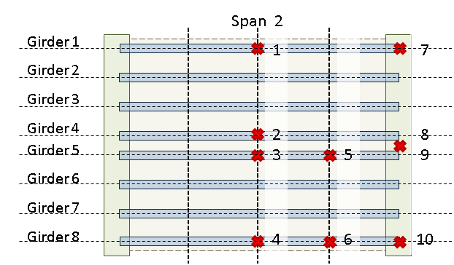



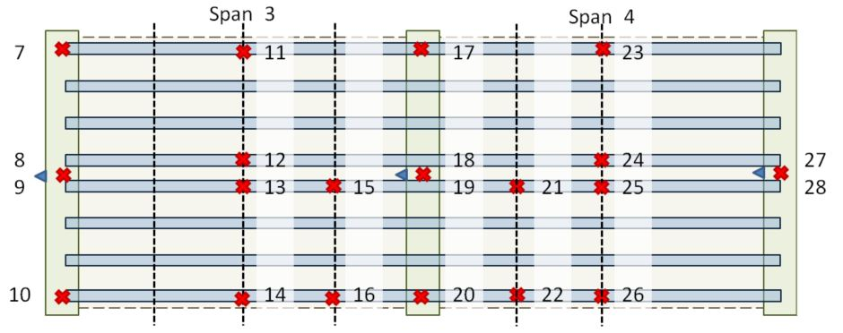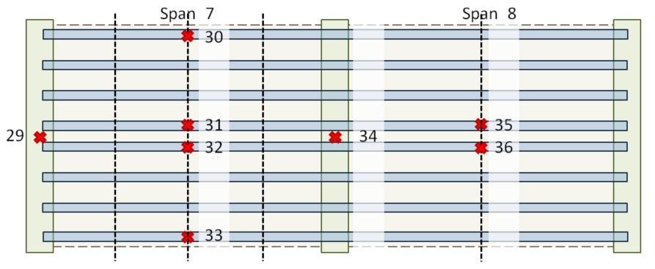

#### Test Activities

The dump truck was generously loaded to a total weight 47940 lbs. (21745 kg) at the DOT truckyard. Truck weight was measured by measuring individual wheel weights with a wheel/axle scale (Intercomp LP600). While it was intended that gauges be placed at the four corners of the truck body, this particular truck body was aluminum and therefore the mounting magnets were ineffectual. The rear two magnets were able to be placed where intended thanks to steel hardware. The front two sensors were attached to the vehicle chassis in-line with the front edge of the bucket. Cables were clamped to the vehicle body and the DAQ was placed under the passenger’s feet who operated the DAQ and recorded meta data.



The test truck traversed the bridge 14 times. Vehicle speed and lane position were varied between runs but kept consistent throughout a single pass. Traffic conditions varied from free-flowing to heavily congested. All 3 DAQs recorded data at 1652 Hz. Crossing events were marked in the data files by a passenger in the test truck by tapping a designated accelerometer just before entering the bridge and just after exiting it. The following table summarizes the meta data for each run.

|  |  |  |  |  |
| --- | --- | --- | --- | --- |
| Run # | Lane | Direction of Travel | Average Speed (mph) | Traffic Conditions |
| 1 | L | WB | 60 – 30 | Stopped near end of bridge |
| 2 | R | EB | 35 | Light |
| 3 | R | WB | 42 | Moderate |
| 4 | R | EB | 25 | Moderate |
| 5 | L | WB | 40 – 0 | Heavy with stop at end |
| 6 | L | EB | 40 | Light |
| 7 | L | WB | 15 | Heavy |
| 8 | L | EB | 47 | Light |
| 9 | L | WB | 58 | Light |
| 10 | R | EB | 20 | Light |
| 11 | R | WB | 10 | Moderate to light |
| 12 | L | EB | 40 | Light |
| 13 | R | WB | 35 | Light |
| 14 | R | EB | 40 | Light |

Accelerometers were removed from the test truck at the conclusion of testing. All sensors were removed from the structure the day after testing.

#### Results & Interpretation

Acceleration records for the bridge show that it was excited by the test truck. As can be seen in the following plot, the structure experiences large vibrations shortly after the test truck enters the span. Data for some channels have been clipped for plot clarity.

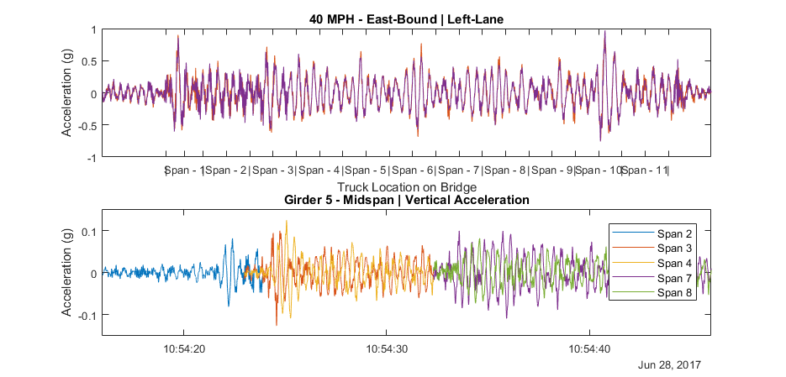

Examination of acceleration records for the test truck reveal that its motion is greatly increased when it is on the bridge deck versus when it is on normal roadway and acceleration increases with increased vehicle speed. The plot below uses the short-time Fourier transform (STFT) to show the frequency content of the truck acceleration as it changes over time. It is evident from the plot that the truck begins to resonate shortly after entering the bridge at a frequency of 2-3Hz.

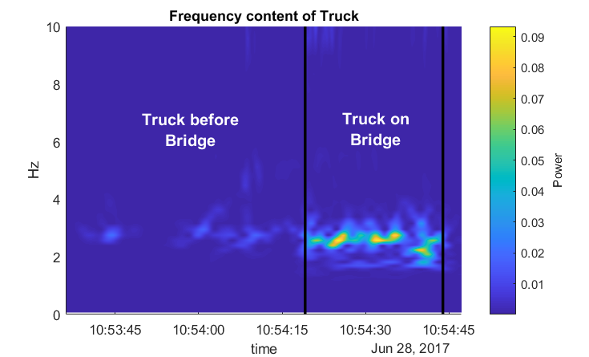

Spectral analysis of truck acceleration data on normal roadway shows the truck has a natural frequency of approximately 2.7Hz. High damping in the vehicle serves to broaden the natural frequency peak, preventing precise modal parameter identification but also providing a range of forcing frequency content that could induce resonance in the truck.



These test results further confirm that the bridge vibrations are a result of vehicle-bridge interaction in which both the vehicle and bridge are experiencing significant excitation. Simulation is required for further understanding of the mechanisms and influential parameters associated with this behavior.

#### FE Simulation

An FE software package was chosen (LUSAS) that was capable of simulating vehicle-bridge interaction. This required the ability to model the geometry and dynamics of the bridge as well as the dynamics of a vehicle traveling over the bridge model. A plate and eccentric-beam (PEB) modelling approach was employed to reduce model complexity in anticipation of computationally heavy simulations. The geometry and material properties were assigned to match those of the 3D FE model that had already been validated. The two-span model detailed below was replicated to produce a model of all 11 spans of the bridge.

##### Plate Eccentric-Beam Modeling

This class of model is much like a grillage model in that the vertical dimension of the bridge is flattened resulting in a 2D model. However, for a PEB model, the girders are offset from the deck plane. For the models used in this study, the offset was specified in the element attributes rather than physically relocating the beam nodes. In this way compatibility between the deck and girders did not need to be explicitly modeled as their nodes were coincident. The cross-girders, in contrast, were modeled at the elevation of their centroidal axis thereby allowing for correct placement of boundary conditions and making it easier for a given box-girder to support adjacent discontinuous spans.



Due to the 2D nature of the model type, the chevron and x-framed diaphragms were represented with 2D beam elements coplanar with the deck. Care was taken to ensure the nodes of these diaphragm beam elements did not coincide with deck nodes except at girder intersections so as to prevent composite action between diaphragms and deck. The diaphragm beam elements were assigned a stiffness such that the structural natural frequencies matched those of the previously validated model and experimental data.



The elevation of those elements which act compositely with the deck is important for accuracy, and while they were modeled on a single plane, the eccentricity of the elements was specified to effectively offset the elements to the correct elevation while maintaining the simplicity of the model. The image above shows the effective elevation of components when rendered with specified eccentricities.

##### Bearings and Pedestals

Beam elements with very high stiffness and zero density (weightless) were used in place of rigid links to connect the cross-girder beam nodes to the stringer nodes since LUSAS does not include rigid links in their element library. These beam elements had all rotation released at the top end. The following table summarizes the additional translational releases assigned. Girders 4 & 5 were also restrained transversely with what is commonly referred to as an alignment bearing.

|  |  |  |  |  |
| --- | --- | --- | --- | --- |
|  | TX | TY | TZ |  |
| Fixed (Pedestals) | F | F | F |
| Expansion (Elastomeric) | R | F | R |
| Expansion (Alignment) | F | F | R |
| F – fixed; R – released | | | |

The cross-girders were assigned boundary conditions by applying restraint to two nodes. Translation was restrained in all three principle directions as well as rotation about the girder’s length. The rotational restraint was necessary to maintain stability and accurately represent the bolted connection between pier and box-girder. The following table summarizes the restraint applied to the nodes at either end of the cross-girder.

|  |  |  |  |  |  |  |  |
| --- | --- | --- | --- | --- | --- | --- | --- |
|  | DX | DY | DZ | RX | RY | RZ |  |
| @ East Piers | F | F | F | F | R | R |
| @ West Piers | R | F | F | F | R | R |
| F – fixed; R – released | | | | | | |

##### Model Updating/Validation

An initial comparison of experimental and model predicted mode shapes revealed that the predicted first bending mode had significantly higher deflection along the exterior of the bridge compared to the experimental results.

|  |  |
| --- | --- |
| FE Predicted 1st Mode | Experimental 1st Mode |

The discrepancy suggested that the exterior regions of the bridge had less mass/greater stiffness, or the center region had greater mass/decreased stiffness. The barriers are the major components that differ for these two regions, therefore these were the first to receive further scrutiny.

Upon re-examination of construction documents and pictures of the bridge it became clear that the center barriers had saw cuts at approximately every twelve feet. These cuts were represented by releasing rotations and longitudinal translation at beam ends (approximately every 12 feet). Alternatively, the stiffness of the barriers could be set nominally low; however, this method tends to create unreal local modes of vibration. The exterior barriers were released over the central supports, as they appeared to be discontinuous at this point in pictures. These releases consisted of all three principle rotations, along with translation in the transverse and longitudinal directions (global).

After making the described adjustments to the barriers in the model, the natural modes and frequencies were recalculated and compared with experimental results. While the shape and frequency of the first mode was now in good agreement, the predicted frequency of a higher mode was nearly 0.4 Hertz lower than that determined experimentally, while the rest of the predicted mode shapes were in good agreement with experimental results.

|  |  |
| --- | --- |
| FE Predicted 3rd Mode – 2.45 Hz | Experimental 5th Mode – 2.8 Hz |

To increase the predicted frequency of this mode, those components that experienced significant curvature were examined first, especially those that experienced relatively little curvature in other modes. The moment of inertia of the I-girders in the negative moment region was checked and found to be consistent with the drawings as well as have little impact on the frequency of the mode.

The central box girder displayed significant deformation for this mode and was the next component to be investigated. The mode was found to be sensitive to its stiffness by studying the effects of altering its moment of inertia. However, as there was a high degree of confidence in the girder’s section properties, the boundary conditions of the box girder were ultimately chosen for modification. The box-girder supports were already represented with fixed translational degrees of freedom as well as rotation about the transverse axis. Rotation about the longitudinal axis was restrained by specifying a spring stiffness of 5x1010 lb-in/rad. This value was determined through incremental adjustment until the predicted and experimental frequencies sufficiently matched.

With the aforementioned adjustments completed, the natural frequency results of the FE model were in good agreement with the experimental results as can be seen in the summary table below.

|  |  |  |  |
| --- | --- | --- | --- |
|  | Experiment | LUSAS FEM | % Error |
| Mode 1 | 2.0 | 2.03 | 1.5% |
| Mode 2 | 2.1 | 2.07 | 1.4% |
| Mode 3 | 2.44 | 2.49 | 2.0% |
| Mode 4 | 2.54 | 2.50 | 1.6% |
| Mode 5 | 2.83 | 2.82 | 0.4% |
| Mode 6 | 3.2 | 3.14 | 1.9% |
| Mode 7 | 3.56 | 3.63 | 2.0% |
| Mode 8 | 3.56 | 3.63 | 2.0% |

##### Full Model

Once the two-span model was satisfactorily modeled, a more comprehensive model was constructed that included all eleven spans of the viaduct. Deck elements were left separated by ½” where discontinuous spans met. Furthermore, by utilizing adjacent “pedestal” elements, the box-girder element could support the two different spans without forcing continuity between their components (deck and girders).

**Connectivity at discontinuous joints**

##### Vehicle Modeling

The vehicle model was developed from the experimental data. The mass of the truck was measured by statically weighing the truck on scales. The acceleration data of the truck was processed using PSD methods and the frequency of the first mode of vibration was determined. Using the relationship for the frequency of a single degree-of-freedom system, the stiffness of the suspension can be determined according to the following equation.

|  |  |
| --- | --- |
|  | (1) |

Analysis of truck acceleration records show a first mode of vibration at 2.8 Hz. Assuming, 45 kips of the truck weight are carried by the suspension, the suspension stiffness is computed to be 36 kip/in. The damping coefficient (cs) was assigned to achieve 10% of critical damping. The coefficient value was therefore calculated by the following equation.

|  |  |
| --- | --- |
|  | (2) |

While the test truck is more complex than a single degree-of-freedom system, effort was first made to see if this simplification could still yield satisfactory results (i.e. responses similar to what was measured in the field).

The initial vehicle model parameter values are summarized in the following table.

|  |  |  |  |  |  |  |  |  |  |  |  |  |  |  |  |  |
| --- | --- | --- | --- | --- | --- | --- | --- | --- | --- | --- | --- | --- | --- | --- | --- | --- |
| |  |  |  | | --- | --- | --- | |  | Value | Units | | ks | 36000 | lb/in | | cs | 410 (10%) | lb-s/in | | ms | 116.55 | lb-s2/in | | mu | 0 | lb-s2/in | |  |

##### Profile Consideration

Initial simulations did not include any roadway profile and therefore inherently assumed a perfectly smooth profile. It very soon became clear that neglecting the roadway profile in the simulations greatly under-predicts the bridge responses. The in-situ roadway profile was subsequently measured for implementation in further simulations.

The profile was recorded using an Ames Engineering Model 8300 Portable Profiler. Two passes were made on each lane. Both wheel lines of the profile were sampled at 1-inch intervals.

Profiles were converted to csv files, each of which contained an array of distances and an array of corresponding elevations for right and left wheel lines using the ProVAL software. MATLAB was then used to convert the data in the csv file so that it could be directly imported into the LUSAS software for simulation. A custom MATLAB script made the following changes to the data:

* Profile is trimmed to a specified distance before the beginning of the bridge
* Distance values are converted to inches and made to start from 0 at the beginning of the profile
* The profile elevation values, over a specified distance from the profile start, are replaced with linearly increasing/decreasing values so as to provide a “ramp” up to the profile
* New distance and elevation arrays are saved to a text file.

The ramp in the profile data prevents the large initial energy input that would result from a sudden step in the profile. A ramp of 20 feet was specified. The profile was trimmed such that it began 500 feet before the beginning of the bridge, allowing ample time for the vehicle to develop its initial conditions. A sample of the profile for an east-bound right lane is shown below.

Simulations were performed with the measured profiles. The vertical acceleration at mid-span of span 3 from simulation with this profile is plotted below and compared with the results from simulation with no profile. These results provide clear indication that the profile has a great influence on vehicle-bridge interaction.

Figure 7: Comparison of span 3 midspan acceleration for simulations with and without a profile included

Figure 8: Comparison of truck vertical acceleration for simulations with and without a profile included

##### Validation of VBI Simulation Methods

In an effort to make simulation results match the experiment, the mass, stiffness and damping of the vehicle model was the adjusted until a good fit was acquired. Damping ratios of 5, 7, 10 and 20 percent were investigated. Mass and stiffness were increased (while maintaining 2.9 Hz frequency) but they were ultimately bounded by the field measurements, and therefore, were relatively certain parameters. Suspension stiffness had minimal effect on truck acceleration, while decreased damping significantly increased truck acceleration. A truck model with the parameters listed in following table above ultimately resulted truck acceleration that best matched the experimental data.

|  |  |  |  |  |  |  |  |  |  |  |  |  |  |  |  |  |
| --- | --- | --- | --- | --- | --- | --- | --- | --- | --- | --- | --- | --- | --- | --- | --- | --- |
| |  |  |  | | --- | --- | --- | |  | Value | Units | | ks | 36000 | lb/in | | cs | 429 (10%) | lb-s/in | | ms | 116.55 | lb-s2/in | | mu | 0.0052 | lb-s2/in | |  |

The following plot compares experimental acceleration data to FE simulation with this vehicle model. Simulations were performed with the path of travel located in center of the right-hand lane of the east-bound side and the measured profile of the right wheel line.

Figure 9: Truck vertical acceleration (simulation vs. experimental)

Figure 10: Bridge vertical acceleration at midspan of span 3

Figure 11: Bridge vertical acceleration at midspan of span 7

These simulation results demonstrate the model’s capability of simulating vehicle-bridge interaction and the role of roadway profile on that interaction.

### Test Conclusions

As a result of the tests performed on the case structure the following may be concluded.

* The bridge is experiencing motion that exceeds human comfort criterion.
* The high vibration levels are occurring on all spans (that were instrumented).
* The bridge exhibits dynamic amplification as high as 1.75 even under heavy vehicles (compared to AASHTO recommended 1.33).
* The high dynamic amplification is not a result of any structural deficiency or anomaly.
* The high dynamic amplification does not seem to pose a risk to the structure’s performance (at strength or service limit states).
* The vehicle is excited by the bridge deck profile, which in-turn excited the bridge
* A validated 3D FE model is capable of simulating bridge-vehicle interaction if roadway profile is included and accurately positioned on the model.

The framework of structural identification was followed throughout the many tests performed on this test structure. In this way testing provided ground truth of behavior which served to validate simulation tools, which were, in-turn, leveraged to investigate structural behavior that would be impossible or impractical to capture in the field. The remainder of this paper implements these validated tools to gain further understanding of vehicle-bridge interaction and dynamic amplification.

## Simulating VBI

In several of the simulation studies described in this section a simplified model was employed. This model is composed of 2 degrees-of-freedom and reduces the bridge to a single beam. This model type was used when appropriate due to the minimal computing power required, permitting a large number of simulations to be automated and performed in a relatively short amount of time. This model (state-space) is described in detail in the second part of this document and in the appendix.

### Bridge and vehicle decoupled

In the interest of further understanding the degree to which the vehicle and bridge interact, the vehicle is analyzed separately from the bridge. The vehicle is first analyzed traveling over just the profile. The contact force obtained as a result of this analysis is then applied to the bridge model. This method neglects bridge motion and therefore represents a completely rigid bridge. Therefore, this method’s accuracy will suffer with increased bridge flexibility and vehicle mass.

|  |  |  |
| --- | --- | --- |
|  |  |  |

Figure 12: Diagram of Decoupled Model

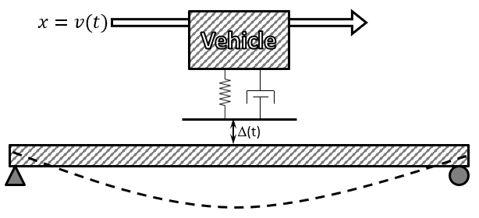

Figure 13: Diagram of Coupled 2-DOF Model

None of the readily available FEM software packages had the capability to apply both time and spatially varying loads, therefore the simplified 2-DOF was used for this demonstration. The following plot compares the bridge response from this uncoupled analysis to that from the coupled vehicle-bridge model.



Despite the simplicity of the model used to obtain the above results, it is still effective at modelling the exchange of energy of two systems. As can be seen, decoupling the bridge and vehicle in simulations reduces the accuracy of the analysis and tends to overestimate the bridge response, especially at higher levels of amplification. It is therefore recommended that any simulation of bridges under vehicle crossings include the interaction of the two systems.

### Mechanisms and Influential Attributes

Many studies on vehicle-bridge interaction will examine the role of parameters separately, and it was the original intention to organize this study in a similar manner. However, as it will soon be made clear, the parameters that effect VBI are interdependent. The following section therefore seeks to demonstrate and characterize the interdependency by first examining roadway profile which the case study showed to be critical to VBI and dynamic amplification.

A given profile is composed of elevation changes over the length of the roadway. This surface may be approximated by a summation of harmonic functions, and thus spectral analysis may be performed in much the same way as was done for acceleration data. The profile can therefore be described by its spatial frequency (cycles per unit distance) content. When a vehicle travels over a harmonic profile, the elevation change experienced at the vehicle’s location is harmonic according to the velocity of the vehicle. A profile with a given spatial frequency will induce a force that acts on the vehicle with a frequency equal to the product of the spatial frequency and vehicle velocity. Therefore, the effect of the profile spatial frequency content is dependent on the velocity of the vehicle.

Several simulations with a 3D FE model (140ft; single-span) were performed for a sinusoidal profile with 30-foot wavelength and ½ in. amplitude. The bridge model had the first and second natural frequencies between 2.2 and 2.5 Hz, while the first natural frequency of the vehicle model was 2.8 Hz. The plot below shows the peak vehicle and bridge response at different vehicle speeds and the resulting forcing frequencies. It is no surprise that the peak responses occur at speeds that induce a forcing frequency that matches their respective natural frequency.

The bridge displacement amplification is calculated by dividing the maximum midspan displacement by the static bridge displacement. The vehicle contact force amplification is calculated by dividing the maximum contact force by the vehicle’s weight.

#### Multi-dimensional parametric study

Additional simulation was performed with the simplified state-space model. Vehicle stiffness was varied to produce vehicle models with natural frequencies ranging from 2 to 5 Hz. Bridge stiffness was also varied to produce bridge models with natural frequencies of the same range. Simulations were performed with the same harmonic profile with a wavelength of 30 ft. Vehicle speeds ranged from 540 to 2400 in/sec (10-136 mph) to produce forcing frequencies between 1.5 and 6.7 Hz.

|  |  |  |  |  |  |
| --- | --- | --- | --- | --- | --- |
|  | Bridge 1 | Bridge 2 | Bridge 3 | Bridge 4 |  |
| Span Length | 100 | 100 | 100 | 100 | ft |
| Mass (total) | 2000 | 2000 | 2000 | 2000 | slinch |
| EI | 5.603E+12 | 1.261E+13 | 2.241E+13 | 3.502E+13 | lb-in2 |
| Damping Ratio | 1.0% | 1.0% | 1.0% | 1.0% |  |
| 1st Nat. Freq. | 2 | 3 | 4 | 5 | Hz |

|  |  |  |  |  |  |
| --- | --- | --- | --- | --- | --- |
|  | Truck 1 | Truck 2 | Truck 3 | Truck 4 |  |
| Mass | 200 | 200 | 200 | 200 | slinch |
| spring k | 31582.7 | 71061.2 | 126330.9 | 197392.1 | lb/in |
| Damping Ratio | 10.0% | 10.0% | 10.0% | 10.0% |  |
| Nat. Freq. | 2 | 3 | 4 | 5 | Hz |

The following plot summarizes the results of this parametric study.

|  |  |  |  |
| --- | --- | --- | --- |
| Bridge Displacement Amplification |  | | Vehicle Contact Force Amplification |
|  | Forcing Frequency (Hz) | Bridge Response  Vehicle Response | |

In the preceding figure the amplification of bridge and vehicle responses is plotted. The bridge displacement amplification is calculated by dividing the maximum midspan displacement by the static response given by the following:

|  |  |
| --- | --- |
|  | (3) |

The vehicle contact force amplification is calculated by dividing the maximum contact force by the static force of the vehicle which is merely the vehicle’s weight.

The above plot demonstrates the role of the profile as well as other parameters in vehicle-bridge interaction. The profile best excites the vehicle when its forcing frequency matches that of the vehicle, and the bridge is most excited when the profile forcing frequency matches its own natural frequency and that of the vehicle.

However even a harmonic profile cannot be entirely described by its frequency content. The distribution of phase angles for the different harmonic components have a large effect on the final form of the profile and how the vehicle-bridge system responds to that profile. The following plot compares bridge response for two profiles with identical frequency content but different phase angle distribution. Simulations were performed with a 3D FE model of a bridge with 140 ft. span length and profiles created according to ISO 8608 standards (C10 = 300; w = -2).

Figure 14: Bridge displacement for profiles with different phase distribution

As can be seen, two profiles with identical frequency content but different phase angle distribution will cause different bridge responses. Similarly, the position of the profile can make a large difference in vehicle and bridge response. Simulations were performed with one of the profiles used in the previous simulation using the 2-DOF simplified model (Bridge 1 & Truck 1). The position of the profile was varied by offsetting it by increments of 5 feet.



As can be seen in the plot above, the bridge response varies greatly by just adjusting the position of the profile on the bridge. Furthermore, most real profiles are not harmonic but rather have many transient features. Profiles that contain features with large wavelengths that result in forcing frequencies similar to vehicles or the bridge should be avoided (e.g 5-50ft.). However, the frequency content of the profile alone has no reliable correlation with dynamic amplification and spatial information must be included in any dynamic amplification analysis.

Vehicle and bridge parameters therefore effect dynamic amplification based on their influence on the dynamics of the system and how those system dynamics relate to the profile characteristics. While parameter effect cannot be quantified they can still be generalized as follows:

* Higher bridge mass, stiffness and damping generally serve to reduce dynamic amplification.
* Higher vehicle mass increases dynamic amplification while vehicle damping helps to reduce amplification.
* Higher vehicle speed leads to increased dynamic amplification.
* Longer bridge length results in a longer period of time for which the vehicle is present on the bridge and may therefore result in greater dynamic amplification.

Anything further than these generalizations requires simulation of vehicle-bridge interaction with the specific profile or direct measurement by field experiment.

# Part 2: Estimating Dynamic Amplification

There are two widely used factors for expressing dynamic amplification. They are referred to as impact factor (IM) and dynamic amplification factor (DAF) and are defined by the following equations:

|  |  |
| --- | --- |
|  | (4) |
|  | (5) |

Therefore, the IM is just . The total live load response can be computed by the following:

|  |  |
| --- | --- |
| or | (6) |

Where Rsta is the static load effect which is amplified by (1 + IM) or the DAF.

In this paper the dynamic amplification factor will be expressed in terms of **equation** 4. The responses used in computing the factor may be any structural response, experimentally recorded or obtained though analysis.

## Visualizing the Problem

The excitation of the vehicle-bridge system is due to the contact force between the vehicle tire and roadway surface. This contact force is dependent on the difference in vertical position of the bridge surface and the vehicle body. The bridge surface elevation is the combination of bridge motion at the vehicle position and elevation added by the profile. It therefore follows that any model of vehicle-bridge interaction must include the following:

* The mass of bridge excited by the vehicle-induced forces
* The stiffness of the bridge
* The mass of the vehicle
* The suspension characteristics of the vehicle
* The vehicle velocity
* The roadway profile accurately positioned on bridge

This last element, an accurately positioned profile, is critical. The effect of a profile feature (bump) is partially dependent on the location of the feature, therefore an accurate model must also include longitudinal (along path of travel) bridge geometry (e.g. span length).

There are many different methods of representing all of these elements in a model, but the success of a model is ultimately judged by its ability to reliably estimate the response of interest. For this study that response of interest is the amplification of peak responses during live load events (vehicle-crossing). The following sections will present several model types of varying complexity, document their construction and demonstrate their ability to predict dynamic amplification.

## In-Situ Measurement

There is no substitute for directly measuring a phenomenon. This section provides guidance on methods of directly measuring the dynamic amplification being experienced by a bridge that is in-service.

### Strain vs. Displacement

In many pieces of relevant literature experimentally derived dynamic amplification factors are reported for both displacement and stress or strain. The displacement factors are almost always greater than those for stress or strain. If a bridge behaves linearly then its response should be linear (i.e. an increase in load by a factor X will result in an increase in response by the same factor, X) regardless of whether the response in question is global (e.g. displacement) or local (e.g. stress, strain). This is not the case with dynamic amplification factors because of a violation of the key assumption that the measured response is due solely to the applied load.

Dynamic amplification factors assume that the bridge response is due to a vehicle which applies a force equal to its weight increased by a factor to account for its dynamic motion (acceleration > gravity). If this assumption were true, dynamic amplification factors would be equal for the various response quantities.

However, the bridge response is actually due to a force applied by the vehicle as well as a force due to the acceleration of the mass of the bridge as it is excited by the dynamic vehicle force (or other excitation sources).

Therefore, the bridge response is the sum of the two responses. To demonstrate this, let’s consider a simply supported beam with a point load placed at midspan. The beam displacement and stress at midspan due to the point load at midspan would equal the following:

* Displacement:
* Stress:

We can assume the beam is oscillating with a sinusoidal mode shape with a maximum acceleration Amax, at midspan. Therefore, the acceleration at any point along the beam can be described by the following equation:

Since the mass of the beam is uniformly distributed along its length, we can describe the maximum force at any point along the beam with the following equation for the equivalent static force:

This equation takes the form of the Newton’s second law of motion: .

The beam displacement and stress at midspan due to this distributed force can then be calculated using statics and the relationship between moment and curvature to produce the following:

* Displacement:
* Stress:

Therefore, the total response would be the sum of the two components, and the amplification factors would take the following form (where the dynamic vehicle force is Av*P):

It can be deduced from the above equations that if vehicle amplification factors are to be used, an additional response must be accounted for by including the second term in the above equations. Furthermore, these equations show that the amplification factor for displacement and stress will be different, and the amplification in excess of the vehicle amplification is greater for displacement than stress (or strain or moment). The ratio of the additional amplification is calculated below.

This shows, that regardless of bridge, or vehicle, the experimental amplification factor for displacement will always be greater than that for stress or moment. It should be noted that these calculations included only the first mode. If more modes were to be included, the equations for amplification factors would take the following form:

The ratio of additional amplification can again be computed.

Additionally, these results are limited to midspan responses. Amplification factors at other locations can be computed in a similar manner, using equations for displacement or stress at other locations. This derivation considers only a simply supported beam and a point load, but the results are still representative of the phenomenon occurring in real structures because the following conditions remain true:

* The vibration of a bridge takes a shape that can be described by a shape function that is a summation of sines.
* The vehicle force is applied to a small area of the bridge and can be reasonable approximated as a point load.

In summary, amplification factors determined with displacement will be greater than those determined from strain (or stress or moment) due to the distribution of load from the mass loading that is ignored in static analysis. Therefore, experimentally determined displacement amplification factors will be a more conservative measure of dynamic amplification, but strain amplification factors remain adequate as strain responses more directly measure the stress experienced by the bridge.

### Operational Monitoring

Often operational monitoring, whereby bridge response is recorded during normal operation, is the cheapest method and least disturbing to traffic and provides responses to typical loading conditions. Members that are expected to experience the largest responses as well as those suspected to have the least reserve capacity should be instrumented. Sensors should be carefully selected based on required response, range, accuracy, etc. This study is principally interested in material level responses (i.e. stress). Strain is directly related stress and thus strain gauges are preferred for measuring dynamic amplification. Displacement gauges can be used but tend to overestimate amplification as discussed previously (Part 1). Acceleration gauges may be used to estimate displacement if they remain accurate at frequencies near zero. This requirement is true of any gauge chosen, but is more likely to be an issue with capacitive accelerometers.

The process of determining dynamic amplification from operational responses has been already detailed by other researchers. Regardless of the exact method used, the data is filtered to remove high frequency content leaving behind the content associated with quasi-static loading. The dynamic amplification is then estimated by computing the ratio of the maximum of the original data to the maximum of the filtered data. A demonstration of this process can be found in the case study presented in the first part.

The filter parameters should be selected such that the pass-band upper limit is less than the first natural frequency but greater than the frequency of loading. In reality, some loading events occur faster than the first natural frequency of the structure. In these cases the filtered response under-estimates static response, subsequently resulting in an over-estimation of amplification. This problem is mitigated by the large mass of the bridge which resists rapid motion, but is always an inherent source of error when estimating static response from operational responses. Furthermore, it is unlikely that the “worst-case” scenario occurred during the record interval and thus the estimated amplification can be non-conservative, but can be appropriate for operational limit states and is a valuable approximation for assessing in-service performance.

### Load Testing

The static response of the bridge can be measured directly when the load is applied statically as in a load test. Responses should be recorded for the test-vehicle (loaded truck) motionless as well as travelling over the bridge at speeds corresponding to minimum, typical, and maximum traffic speeds. Dynamic amplification computed from the resulting static and dynamic responses will be accurate for that specific test-vehicle, but is not guaranteed to remain conservative for all loading events. A bridge’s performance in design or evaluation is measured by its ability to carry limit-state loads. Test-vehicles should therefore be loaded to a weight similar to the legal load limit. When possible, test-vehicles should also be chosen with a body-bounce natural frequency similar to that of the first-bending mode of vibration of the bridge as this has been shown to result in the greatest dynamic amplification.

The test-vehicle should be placed at locations that produce maximum response or made to “crawl” at speeds low enough to maintain “quasi-static” conditions for the static portion of the load test. The dynamic load test should occur at various speeds and along all paths of travel. The test vehicle must begin a significant distance from the start of the bridge to account for vehicle motion as a result of traversing the approach roadway. The test-vehicle should maintain the set speed from a distance of at least 65 feet (20 meters) away from the beginning of the bridge until it exits the bridge.

### Profile Measurement

In some cases it becomes necessary to simulate the bridge response to moving vehicles. Any simulations of vehicle-bridge interaction must include bridge deck profile. The profile should contain paired position and elevation information along the entire length of the bridge and approach roadway for every reasonable path of travel. Elevation data may be recorded along a single line or along multiple wheel lines. The spatial resolution should be set small enough to capture all features of interest. Bridge motion is most effected by profile features with a length of several feet and more. Commercial profilographs have sampling intervals on the order of one inch and thus can be expected to produce adequate profile measurements.

## Finite Element Analysis

There are often scenarios in which it is impractical or even impossible to implement certain loading events or measure certain responses. In such circumstances it becomes necessary to perform simulation of the loading event to predict expected responses. The selection and construction of a suitable model for these simulations is critical to accurate predictions.

A 3D element-level FE model is capable of representing all mechanisms and features that are a part of vehicle-bridge interaction and influence dynamic amplification. By creating a model that is geometrically consistent with the real structure the mass and stiffness can be accurately modeled and spatially distributed. The model should be error-screened and calibrated with experimental data from the real structure and should have at least the first natural frequency matching that of the real structure.

It is not the aim of this paper to provide guidance on constructing and validating FE models. The exact methods of model construction and analysis are dependent on the FE software package employed. The selected FE software should be capable of simulating moving sprung masses over a specified profile and bridge model. The model should be constructed using best practices and should be validated with experimental data whenever possible. Validation with dynamic data (e.g. frequencies and mode shapes) is preferable and ensures the model dynamics match those of the structure.

The vehicle can be modeled after a real vehicle by assigning equivalent mass (weight) and by setting suspension characteristics that result in matching body-bounce natural frequencies. If there is no reference vehicle, a worst-case vehicle model may be created that has a mass equal to the legal limit, low damping (e.g. 10%), and a suspension stiffness that results in a body-bounce frequency 10% greater than the bridge’s first-bending natural frequency.

Static responses can be simulated with vehicle at a crawl-speed (i.e. <1mph) or with a static linear analysis of the vehicle placed in locations that produce maximum response. Simulated responses should be recorded at locations of maximum response or particular vulnerability. Dynamic amplification can be computed for a given location as the ratio of maximum dynamic response to maximum static response.

The case study provided in the first part of this document demonstrates the process of estimating dynamic amplification with 3D FE analysis.

## 2D Condensation & State-Space

Although 3D FE analysis is capable of accurately simulating vehicle-bridge interaction and estimating dynamic amplification, it is often impractical for current engineering practice due to the required time and expertise. It is therefore advantageous to develop models that require minimal time and expertise while still providing accurate estimates of dynamic amplification.

### Description

The following pages present a model type that includes all of the mechanisms involved with vehicle bridge motion as listed in the beginning of this part. The model reduces the bridge to a generalized single degree-of-freedom (SDF) system for which its deformation at any point along the bridge’s length is defined by a shape function. The vehicle is also represented as a single sprung mass and is coupled to the bridge degree-of-freedom. The equations of motion for this generalized SDF system are relatively simple and are used to develop state-space equations that define the position of both bridge and vehicle. The following image illustrates the model components.

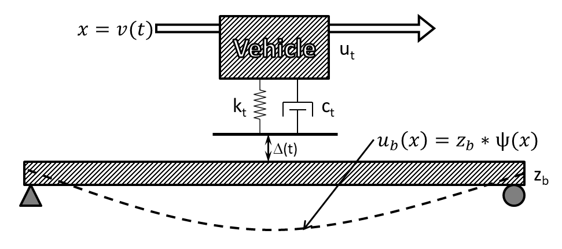

Models were developed for single-span bridges and for 2-span continuous bridges with equal span lengths. Although these models include every mechanism that plays a role in dynamic amplification they have several inherent limitations:

1. A sine wave () was chosen for the shape functions that generalize the distributed systems by defining the shape of the beam deformation. While this shape function accurately describes the deformation associated with the first-bending mode of vibration, it is incorrect for point loading (or any other loading).
2. The single shape function cannot account for the excitation of the bridge’s higher modes of vibration.
3. By modeling the bridge as a single beam, the lateral distribution of mass and stiffness is neglected.

While these and other limitations leave the models much less capable than a full 3D FE model, they prove useful for estimating dynamic amplification and require a fraction of the time investment and computing power.

#### Single Span

This state-space model is developed from the equations of motion for a single sprung mass traveling over a simple-supported beam with distributed mass and stiffness. The beam is reduced to a single degree-of-freedom by generalizing its displacement according to a shape function. A sinusoidal shape function was chosen to capture the excitement of the beam’s first mode of vibration (1st bending). The beam has a uniform stiffness parameter (EI), uniform mass distribution (), and equal span lengths (L). Mass distributed damping of the beam is included. The vehicle is reduced to a single point mass (*m*t) with specified spring stiffness (kt), viscous damping coefficient (ct), and traveling at a specified velocity (*v*).

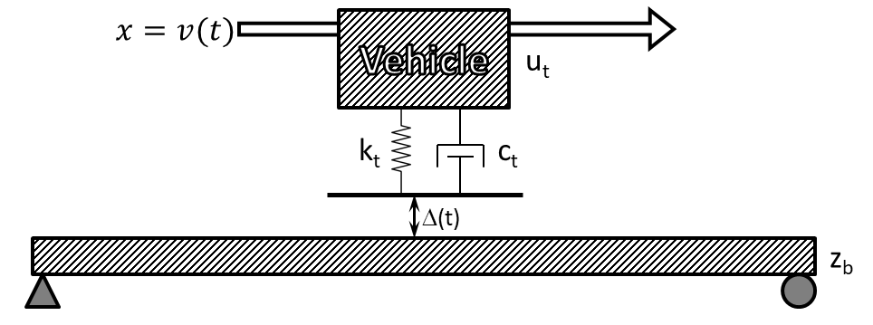

##### Assumed deformation shape function

The beam is assumed to deform with a half sine function (i.e. wavelength is twice the length of the span). That function is described by the following equation.

for

Therefore, the deflection and velocity of the beam at the vehicle’s location at time (t) is described by the following equations.

##### Generalized mass, stiffness and damping

The generalized mass and stiffness properties for the beam can be calculated as follows.

The generalized damping property is defined by the following equations for mass distributed damping. The generalized damping is given by the following equation.

Where *a* is the mass-proportional damping coefficient. The damping ratio is defined by the following equation.

Thus, the damping coefficient (a) may be determined based on a specified damping ratio () using the following equation.

By substitution, the generalized damping property may be expressed as follows.

##### Force transformation

The force applied by the vehicle mass (p0) must also be generalized. It’s position and magnitude are mathematically described as follows:

Where is the Dirac delta function centered at , and . The generalized force is therefore calculated as follows for .

The force (p0) applied by the vehicle is calculated based on the relative vertical motion of bridge and vehicle, including profile elevation, as shown below.

##### Equations of motion for when vehicle is on bridge

The equations of motion of the generalized beam and moving vehicle may therefore be composed as follows for .

Vehicle DOF:

Beam DOF:

##### State Space

The states of this system may therefore be defined as follows:

; ; ;

The profile elevation and velocity are assigned to matrix *u*.

;

The equations of motion are reorganized in terms of the defined states as follows.

;

When the vehicle is off the bridge, the bridge experiences free vibration and the vehicle’s motion is independent of the bridge motion. The state-space matrices for this condition are provided as follows.

#### Two-span Continuous

This state-space model is developed from the equations of motion for a single sprung mass traveling over a 2-span continuous beam with distributed mass and stiffness. The beam is reduced to a single degree-of-freedom by generalizing its displacement according to a shape function. A sinusoidal shape function was chosen to capture the excitement of the beam’s first mode of vibration (1st bending). The beam has a uniform stiffness parameter (EI), uniform mass distribution (), and equal span lengths (L). Mass distributed damping of the beam is included. The vehicle is reduced to a single point mass (*m*t) with specified spring stiffness (kt), viscous damping coefficient (ct), and traveling at a specified velocity (*v*).

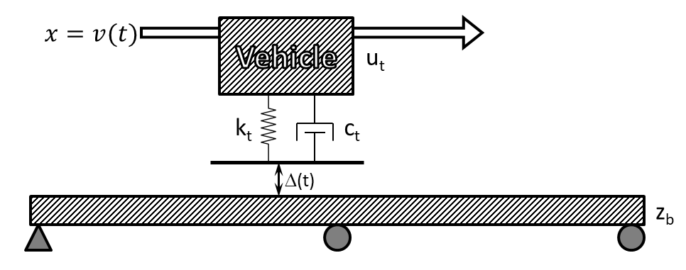

##### Assumed deformation shape function

The beam is assumed to deform with a half sine function (i.e. wavelength is twice the length of a single span). That function is described as follows.

for

Therefore, the deflection and velocity of the beam at the vehicle’s location at time (t) is described by the following equations.

##### Generalized mass, stiffness and damping

The generalized mass and stiffness properties for the beam can be calculated as follows.

The generalized damping property is derived in the same manner as was done for the single-span model. defined by the following equations for mass distributed damping.

##### Force transformation

The force applied by the vehicle mass (p0) must also be generalized. It’s position and magnitude are mathematically described as follows:

Where is the Dirac delta function centered at , and . The generalized force is therefore calculated as follows for .

The force (p0) applied by the vehicle is calculated based on the relative vertical motion of bridge and vehicle, including profile elevation, as shown below.

##### Equations of motion for when vehicle is on bridge

The equations of motion of the generalized beam and moving vehicle may therefore be composed as follows for .

Vehicle DOF:

Beam DOF:

##### State Space

The states of this system may therefore be defined as follows:

; ; ;

The profile elevation and velocity are assigned to matrix *u*.

;

The equations of motion are reorganized in terms of the defined states as follows.

;

When the vehicle is off the bridge, the bridge experiences free vibration and the vehicle’s motion is independent of the bridge motion. The state-space matrices for this condition are provided as follows.

### Implementation

The first step in determining the appropriate parameters for defining the state-space model is to define a beam that can approximate bridge response due to a vehicle traveling along specified path of travel. The distributed stiffness (EI) can be approximated by first determining the stiffness of the bridge to a point load at midspan along the path of travel. This stiffness value (Kmid) may be determined experimentally or with a refined FE model. The appropriate EI value is subsequently calculated using the Mechanics of Materials solutions for midspan displacement. Stiffness is assumed to be uniformly distributed (i.e. EI is constant along the length of the beam). The following equations describe that calculation for single-span and two-span models.

|  |  |
| --- | --- |
| Single Span: | (7) |
| Two-Span: | (8) |

Once the distributed stiffness of the beam is determined, the distributed mass of the beam may be calculated such that the beam has a first-bending natural frequency equal to that of the bridge. Mass was assumed to be uniformly distributed along the length of the beam for the models presented herein. The total bridge mass may therefore be calculated with the following equation.

|  |  |
| --- | --- |
|  | (9) |

The vehicle is also reduced to a single degree-of-freedom based on known mass and natural frequency as described for FE simulations. Conservative vehicles may be implemented that have mass equal to legal limits and suspension stiffness that results in a body-bounce natural frequency approximately 10% greater than the bridge natural frequency. The suspension spring stiffness may be calculated according to the following equation.

|  |  |
| --- | --- |
|  | (10) |

The profile should be measured and provided in the form of sequential distance and elevation measurements. The distance values should be monotonically increasing.

With all parameter values obtained and assigned, the scenario may be simulated by stepping through each time increment, solving each “state” in-turn. This is easily accomplished programmatically with a loop. Full instruction on how to implement the state-space model is provided in the appendix and accompanying computer code is available upon request (if not already publicly available).

While the state-space model directly computes bridge displacement, the amplification (and other response quantities) is easily computed and is the quantity reported in many of the supporting figures. It became quickly evident that the error of these simplified models was mitigated by computing amplification rather than deflection. This is not surprising as it serves to reduce the effect of bridge stiffness, a parameter which is represented in vastly different ways (3D element-level vs SDF). It should also be noted that structural responses (e.g. displacement) should not be interpreted directly from these simplified models. Rather these models are intended to predict the amplification of responses.

### Validation

The models previously described were implemented in MATLAB. The models were error screened by first comparing output to FE models of corresponding beams. Simulations were performed for which a single sprung mass traversed the beams at 720 in/sec over an artificial profile created using ISO 8608 methods. Specific details regarding these simulations are provided in the appendix.

Comparison of FEM results to state-space model results are provided by the following plots. Some error was expected (and observed) because the state-space models are still an approximate representation of beam behavior. That error was more pronounced for models of two-span continuous beams.

The disagreement evident in the preceding plots may be contributed to the simplicity of the state-space model compared to the FE model. In reducing the beam to a single degree-of-freedom, the state-space model assumes all deformation occurs according the specified shape function. While this function is accurate for the first mode of vibration, it is less adequate at describing the deformation due to concentrated loading as presented by the moving sprung mass. This assumption also ignores contribution from other modes. These higher modes were not included in the simulations presented in the preceding plots to provide a more direct comparison, but they do contribute to responses, especially those modes with low frequencies.

Due to the nature of two-span continuous bridges, the second bending mode is likely to occur at a frequency near to that of the first-bending mode. Thus, simulations that only consider the first mode will suffer greater inaccuracy when performed for two-span continuous bridges. The following plot compares the FE simulation of the two-span beam model with only the first mode included, and with the first five modes included.

### Performance Assessment

It is always preferable to measure a model against ground truth values, which in this case would be the dynamic amplification as recorded on an actual structure. However, there are not enough structures that have been instrumented for the determination of dynamic amplification and have also had their profile measured. There are simply too few samples from real structures to adequately assess the performance of the state-space models. As a result, the performance of the state-space models was evaluated by comparing the dynamic amplification predicted by the model to that predicted by a 3D FE model. A total of six 3D FE models were constructed based on actual structures that had been previously subjected to dynamic testing. The roadway width of some of the models was great enough to accommodate multiple lanes and therefore multiple paths of travel were defined. A more detailed description of the FE models is provided in the appendix.

A total of 15 profiles were evaluated. Three of the profiles were obtained from the profiles recorded from the case study bridge. Another twelve were artificial and generated using the methods defined by the ISO 8608 standards. This standard defines a roughness metric, but also describes the process whereby the profile is defined by frequency content and is generated through the summation of sine functions.

Several vehicles were defined with parameters that resulted in body-bounce natural frequencies equal to the first natural frequencies reported by the FE models. The mass of all vehicles was set to 200 slinches (77.2 kips). Three vehicle models were assigned damping ratios of 10%; one was assigned 20%. Further description of modeling decisions and parameters are provided in the appendix.

The four parameter categories (i.e. bridge, path of travel, vehicle, and profile) were sampled to obtain a total of 239 different scenarios. Each scenario was simulated with a detailed 3D FE model and with a state-space model. The predicted amplification is compared in the plots below. It can be observed from these plots that the state-space models are more conservative for scenarios that result in high levels of amplification, but more accurate at lower amplification levels. It is not expected that dynamic amplification will reach such high values on real structures. These values were obtained in simulations with unrealistically rough artificial profiles, but still serve to demonstrate the performance of the state-space models.

## IRI & Other Vehicle-Only Models

There are several methods already widely used to assess the roughness of roadway profiles. The International Roughness Index (IRI) is the most complex and simulates a specified vehicle (golden quarter-car) traveling over the profile. Other metrics ignore the vehicle and deal only with the profile data. The ISO 8608 parameters, for example, describe the spatial frequency content of the profile. However, all of these roughness metrics fail to consider the bridge or the position of the profile. Studies were performed to examine if these metrics had any ability to predict dynamic amplification.

ISO 8608 parameters describe the spatial frequency content of the profile. Studies presented in the first part of this document show that the spatial frequency of the profile content does influence dynamic amplification. However, these parameters ignore any transient features and ignore the phase angle distribution and therefore are inadequate for predicting dynamic amplification. This is evidenced by the plot below which compares the bridge response for two profiles with identical ISO parameters but different distribution of phase angles. The inadequacy is further demonstrated by the supplied correlation plot.

PLOTs

The IRI includes the vehicle in its model and may be expected to demonstrate better ability to predict dynamic amplification. However, a correlation plot shows that the IRI cannot reliably predict dynamic amplification. The plot also reveals that while profiles with high IRI may not always result in high dynamic amplification, bridges with high dynamic amplification have high profile IRI values. This provides further encouragement to encourage and mandate a smooth deck surface.

PLOT

Another simple model was assessed that included representation of the vehicle, but ignored bridge behavior. Position of the profile on the bridge was included by applying a sine window to the vehicle response over the time period for which the vehicle is on the bridge. The maximum of the windowed contact force is reported as a factor of the vehicle self-weight. This contact-force amplification metric is compared to FE predictions in the plot below. The metric consistently correlated with dynamic amplification for some bridges, but was not widely applicable and therefore is not recommended for any amplification predictions.

PLOT

## Summary

* The vehicle and bridge comprise a coupled dynamic system that is energized by the vehicle traversing a profile.
* Dynamic amplification estimated by filtering operational monitoring data may over-estimate amplification.
* Determining dynamic amplification of in-service bridges may be performed with operational monitoring or a load test. In either case, strain gauges are recommended over displacement gauges or accelerometers.
* A 3D FE model is capable of simulating vehicle-bridge interaction and is recommended for predicting dynamic amplification for structures with complex geometry or that are otherwise ill-suited to the state-space models.
* A simple model that reduces both the bridge and vehicle to SDF systems has been shown to reliably predict dynamic amplification, and is recommended if FE simulation is not practical.
* Any metric that is to be used for predicting dynamic amplification must include a representation of the bridge. Therefore dynamic amplification should not be predicted by current roughness metrics (e.g. IRI and ISO 8608) that only consider the profile and vehicle.

# Part 3: Applications in Vehicle-Bridge Interaction

Several tools have been shown capable of simulating vehicle-bridge interaction and are leveraged in the following pages to further our understanding of dynamic amplification.

## Remediation and Smoothness Criteria

If a bridge is suspected to exhibit large dynamic amplification as a result of a rough roadway, the bridge owner may wish to grind the roadway smooth. Furthermore, to reduce dynamic amplification in new construction, deck profile specifications should provide smoothness targets. Currently, smoothness criteria are prescribed differently for different locations. Most US states

The ability of these criteria to limit dynamic amplification is assessed by examining a problematic profile, and then evaluating the reduction in amplification if the profile is smoothed according to specified criteria.

The IRI which is widely used as a smoothness criterion by providing upper limits, has already been shown to influence dynamic amplification. The IRI is a measure of vehicle response and can therefore only be implemented as a performance metric. As such it provides no methods for specifying or monitoring of smoothness during construction or grinding and will not be presented in this section. However, if a deck profile is shown to have a high IRI, intervention should be considered.

Rolling straightedge requirements are widely used for specifying localized roughness criteria and are expressed in terms of deviation over a certain length. Parameters commonly range from 1/8 to ¼ inch deviation over a 10 to 16 foot distance. The plots below illustrate the ability of straightedge requirements to limit dynamic amplification.

PLOTS

The straightedge requirements effectively target features within a range of lengths. At normal traffic speeds profile features with lengths of **5-20 feet** result in forcing frequencies within the range of natural frequencies commonly exhibited by bridges. Therefore, the straightedge length should be specified long enough to avoid/remove long features. The effects of a variety of straightedge lengths are compared below.

PLOT

## Vehicle Configurations

The many simulations that have thus far been reported, have considered a single vehicle traversing a bridge. In reality, bridges experience a large variety of different live-load configurations and many times are subjected to multiple vehicles at the same time.

### Traffic

The scenario of multiple-vehicle loading is accounted for in most design methodologies through the use of multi-presence factors. These factors serve to reduce the load presented by vehicles in adjacent lanes based on the assumption that vehicles with legal-limit weights are unlikely to occupy adjacent lanes at the same time. While this assumption may be valid for bridge response to static loads, other vehicles, including light vehicles (e.g. small passenger vehicles) may contribute to the dynamic response. The effect of other vehicles (traffic) on a bridge’s dynamic response and the dynamic amplification of a major load event are investigated.

### Truck Trains

### Future Work